★★☆☆☆
題組：基礎48題
題號：Q101: The Blocks Problem
整理者：鄭紹雄
學號：ACS105103
使用語言:C++
解題日期：2018年7月14日
題目:
Many areas of Computer Science use simple, abstract domains for both analytical and empirical studies.
For example, an early AI study of planning and robotics (STRIPS) used a block world in which a robot arm performed tasks involving the manipulation of blocks.
In this problem you will model a simple block world under certain rules and constraints. Rather than determine how to achieve a specified state, you will “program” a robotic arm to respond to a limited set of commands.
The problem is to parse a series of commands that instruct a robot arm in how to manipulate blocks that lie on a flat table. Initially there are n blocks on the table (numbered from 0 to n − 1) with block bi adjacent to block bi+1 for all 0 ≤ i < n − 1 as shown in the diagram below:
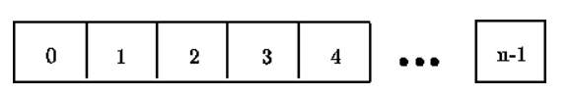
Initial Blocks World
The valid commands for the robot arm that manipulates blocks are:
• move a onto b
where a and b are block numbers, puts block a onto block b after returning any blocks that are stacked on top of blocks a and b to their initial positions.
• move a over b
where a and b are block numbers, puts block a onto the top of the stack containing block b, after returning any blocks that are stacked on top of block a to their initial positions.
• pile a onto b
where a and b are block numbers, moves the pile of blocks consisting of block a, and any blocks that are stacked above block a, onto block b. All blocks on top of block b are moved to their initial positions prior to the pile taking place. The blocks stacked above block a retain their order when moved.
• pile a over b
where a and b are block numbers, puts the pile of blocks consisting of block a, and any blocks that are stacked above block a, onto the top of the stack containing block b. The blocks stacked above block a retain their original order when moved.
• quit
terminates manipulations in the block world.
Any command in which a = b or in which a and b are in the same stack of blocks is an illegal command. All illegal commands should be ignored and should have no affect on the configuration of blocks.
Input
The input begins with an integer n on a line by itself representing the number of blocks in the block world. You may assume that 0 < n < 25.
The number of blocks is followed by a sequence of block commands, one command per line. Your program should process all commands until the quit command is encountered.
You may assume that all commands will be of the form specified above. There will be no syntactically
incorrect commands.
Output
The output should consist of the final state of the blocks world. Each original block position numbered i (0 ≤ i < n where n is the number of blocks) should appear followed immediately by a colon. If there is at least a block on it, the colon must be followed by one space, followed by a list of blocks that appear stacked in that position with each block number separated from other block numbers by a space. Don’t put any trailing spaces on a line.
There should be one line of output for each block position (i.e., n lines of output where n is the integer on the first line of input).
Sample Input
10
move 9 onto 1
move 8 over 1
move 7 over 1
move 6 over 1
pile 8 over 6
pile 8 over 5
move 2 over 1
move 4 over 9
quit
Sample Output
0: 0
1: 1 9 2 4
2:
3: 3
4:
5: 5 8 7 6
6:
7:
8:
9:
問題描述：
在早期人工智慧的領域中常常會用到機器人，在這個問題中有一支機器手臂接受指令來搬動積木，而你的任務就是輸出最後積木的情形。
一開始在一平坦的桌面上有n塊積木（編號從0到n-1）0號積木放在0號位置上，1號積木放在1號位置上，依此類推，如下圖。
機器手臂有以下幾種合法搬積木的方式（a和b是積木的編號）：
move a onto b
在將a搬到b上之前，先將a和b上的積木放回原來的位置（例如：1就放回1的最開始位罝）
move a over b
在將a搬到b所在的那堆積木之上之前，先將a上的積木放回原來的位罝（b所在的那堆積木不動）
pile a onto b
將a本身和其上的積木一起放到b上，在搬之前b上方的積木放回原位
pile a over b
將a本身和其上的積木一起搬到到b所在的那堆積木之上
quit
動作結束
前四個動作中若a=b，或者a, b在同一堆積木中，那麼這樣的動作算是不合法的。所有不合法的動作應該被忽略，也就是對各積木均無改變。

Input
輸入含有多組測試資料，每組測試資料的第一列有一個正整數n（0 < n < 25），代表積木的數目（編號從0到n-1）。接下來為機器手臂的動作，每個動作一列。如果此動作為 quit ，代表此組測試資料輸入結束。你可以假設所有的動作都符合上述的樣式。請參考Sample Input。
Output
每組測試資料輸出桌面上各位置積木的情形（每個位置一列，也就是共有n列），格式請參考Sample Output。
Sample Input
10
move 9 onto 1
move 8 over 1
move 7 over 1
move 6 over 1
pile 8 over 6
pile 8 over 5
move 2 over 1
move 4 over 9
quit
4
pile 0 over 1
pile 2 over 3
move 1 onto 3
quit
Sample Output
0: 0
1: 1 9 2 4
2:
3: 3
4:
5: 5 8 7 6

解法：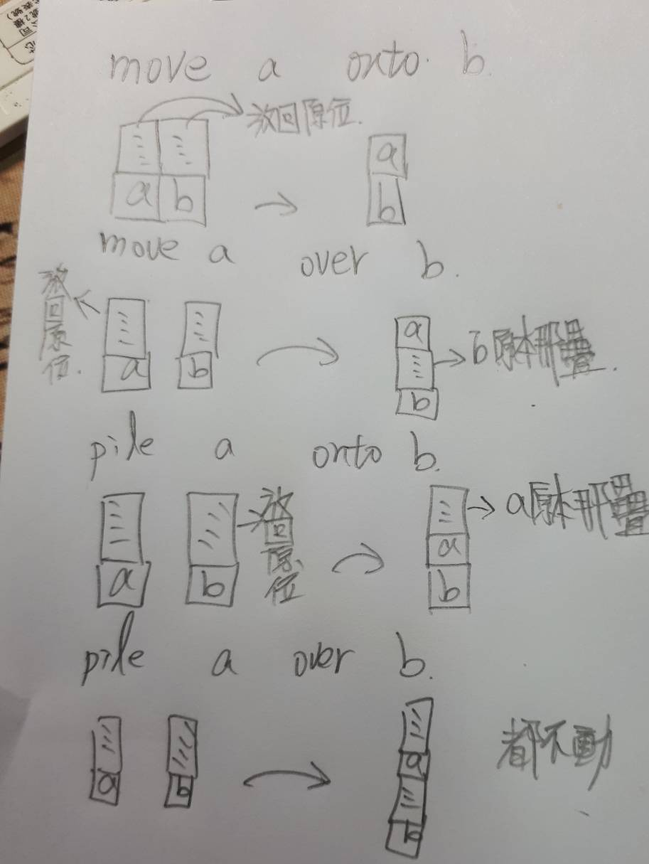
如上圖每一項的邏輯是這樣，再由vector陣列去做處理，該送回去的東西送回去排在後面

解法範例：
// 1.先設定二微陣列vector put
// 2.依照n塊積木去初始化put
// 3.輸入指令
// 4.依照指令從事以上動作
// 5.發現a、b在同一個位子上為無效輸入，退回3
// 6.若發現輸入quit則停止，若沒有的話退回3
討論：
//1.輸入使用C語言scanf會加快程式執行速度
//2.二維vector的使用須了解
//3.注意!走訪中不可以填加或刪除元素會導致系統崩潰!!
//4.宣告後一定要初始化，不然會有魔術數字
程式：
#include <iostream>
#include <vector>
#include <cstdio>

using namespace std;

int main(){

int n;
//輸入n值
while(scanf("%d",&n)!=EOF){

//宣告二維vector put
vector< vector<int> >put;
//給予put記憶體空間
put.reserve(1000);

int i;
string first;

//初始化put
for(i=0;i<n;i++){
vector<int>re;
re.push_back(i);
put.push_back(re);
}

//開始輸入指令
while(cin>>first){
//輸入到quit則退出
if(first=="quit"){
break;
}
int a=0,b=0;
int X=0,Y=-1;
string second;
cin>>a>>second>>b;
//發現a=b時(同一個方塊)，忽略此行指令重新輸入
if(a==b){
continue;
}

//尋找a、b在哪一個位子上
for(i = 0 ; i < n ; i++){
for(int j = 0;j < put[i].size();j++){
if(put[i][j]==a){
X=i;
}else if(put[i][j]==b){
Y=i;
}
}
}
//發現X=Y(發現a、b在同一行位子)時，忽略此行指令重新輸入
if(X==Y){
continue;
}
// move a onto b
if(first=="move"&&second=="onto"){
int count1= 0,count2 = 0;

//先將a方塊上的方塊送回她原本的地方
for(i=0;i<put[X].size();i++){
if(put[X][i]==a){
count1 = i++;
for(;i<put[X].size();i++){
int inte=put[X][i];
put[inte].push_back(inte);
}
}
}
//清除原本a方塊上面的方塊
put[X].erase(put[X].begin()+count1,put[X].end());

//先將b方塊上的方塊送回她原本的地方
for(i=0;i<put[Y].size();i++){
if(put[Y][i]==b){
count2 = i++;
for(;i<put[Y].size();i++){
int inte=put[Y][i];
put[inte].push_back(inte);
}
}

}
//清除原本b方塊上的方塊
put[Y].erase(put[Y].begin()+count2+1,put[Y].end());
//將a方塊放到b方塊上
put[Y].push_back(put[X][count1]);

// move a over b
}else if(first=="move"&&second=="over"){
int count1= 0,count2 = 0;
//先將a方塊上的方塊送回她原本的地方
for(i=0;i<put[X].size();i++){
if(put[X][i]==a){
count1 = i++;
for(;i<put[X].size();i++){
int inte=put[X][i];
put[inte].push_back(inte);
}
}
}
//清除原本在a方塊上的方塊
put[X].erase(put[X].begin()+count1,put[X].end());

//將a方塊放到b方塊上
put[Y].push_back(put[X][count1]);

//pile a onto b
}else if(first=="pile"&&second=="onto"){
int count1= 0,count2 = 0;
//先將b方塊上的方塊送回她原本的地方
for(int i=0;i<put[Y].size();i++){
if(put[Y][i]==b){
count2 = i++;
for(;i<put[Y].size();i++){
int inte=put[Y][i];
put[inte].push_back(inte);
}
}

}
//清除b方塊上的方塊
put[Y].erase(put[Y].begin()+count2+1,put[Y].end());

//將a方塊跟他上面的方塊放到b方塊上
for(int i=0;i<put[X].size();i++){
if(put[X][i]==a){
count1 = i;
for(;i<put[X].size();i++){
put[Y].push_back(put[X][i]);
}
break;
}
}
//清除原本將a方塊跟他上面的方塊
put[X].erase(put[X].begin()+count1,put[X].end());

//pile a over b
}else if(first=="pile"&&second=="over"){
int count1= 0,count2 = 0;
//將a方塊跟他上面的方塊放到b方塊上
for(i=0;i<put[X].size();i++){
if(put[X][i]==a){
count1 = i;
for(;i<put[X].size();i++){
put[Y].push_back(put[X][i]);
}
}
}
//清除原本將a方塊跟他上面的方塊
put[X].erase(put[X].begin()+count1,put[X].end());

}

}
for(i = 0 ; i < n ; i++){
cout<<i<<":";
for(int j = 0;j < put[i].size();j++){
cout<<" "<<put[i][j];
}
cout<<endl;
}

}

return 0;
}

